 | Recommendations for the representation of hierarchical objects in Europeana
Contributors

Alessia Bardi, HOPE project
Allison Kupietzky, The Israel Museum, Jerusalem
Antoine Isaac, Europeana Foundation
Dan Matei, CIMEC
Donald Weber, HOPE project
Kerstin Arnold, Bundesarchiv, APEx project
Maria Luisa Martinez Conde, Ministry of Culture Spain
Michael Fingerhut, Bibliomus.org
Robina Clayphan, Europeana Foundation
Rodolphe Bailly, Cité de la musique
Stefanie Rühle, Goettingen State and University Library
Valentine Charles, Europeana Foundation
Xavier Agenjo, Fundación Ignacio Larramendi

Executive Summary 3
1. Introduction and scope of this report 4
2. Methodology and case studies 5
3. Typology of hierarchies 7
3.1. Main types of hierarchies 7
3.2. Hierarchical structures in Archives 9
3.3. Other hierarchical structures - deemed out-of-scope 12
4. Representing hierarchies using the Europeana data model – solutions / patterns / practices 14
4.1. What can be included in hierarchies? 14
4.2. Representing missing parts 23
4.3. How to sequence parts in EDM? 28
4.4. Data propagation - inheritance 30
5. Display/access for hierarchical objects in Europeana 31
5.1. Searching hierarchical objects 31
5.2. Presentation of the hierarchies 31
5.3. Navigation from one level to another one 35
6. Conclusion 39
References 40
Annexes 41
Annex 1: Hierarchical objects Task Force Charter (see below) 41
Annex 2: xml source data describing a situation where the semantic structure and the physical structure on the child level of the hierarchy are one to one. (Figure 2 in the report) 41
Annex 3: xml source data describing hierarchies in WebResources (Figure 12 in the report). 41
Annex 4: xml source data describing sequential relationships between ProvidedCHOs (Figure 21 in the report). 41
Annex 5: Cases studies 41

Executive Summary
The issue of handling hierarchical objects has been always an important topic for Europeana’s network of projects and Data Providers. The implementation of solutions in the Europeana portal has been delayed for a long time mainly due to the fact that complex objects required the development of new functionalities that could not be supported by the Europeana Semantic Elements (ESE) model. Indeed the simplicity and the flatness of this model prevented Data Providers from supplying complex objects.

The creation of this Task Force has been motivated by the creation and implementation of the Europeana Data Model (EDM) in Europeana. EDM enables a semantic approach to data modelling and therefore offers possibilities of describing relationships between objects and representing complex data. The work of the group was to agree a set of definitions on what a hierarchical object is by examining a range of hierarchical object cases. Its overall objective is to provide a set of solutions and recommendations on how to represent these different cases by using EDM.

Using examples provided by members of the Task Force the report examines the various types of hierarchy that can be found in the cultural heritage domain. Such structures are characterised by vertical (whole/part relationships) and horizontal (sibling) relationships. It describes three main types:
- the most typical type consists of hierarchies of cultural heritage objects – such as a serial publication having volumes, issues and articles – which can be seen to form a tree structure of the same or similar types of object. A variation of this is a straightforward hierarchy which also contains “contextual” resources - such as a series of concerts (“event” objects) with individual concerts and individual works as constituent parts.
- secondly, are the hierarchical structures found in Archives which typically reflect the administrative structure and/or functions of the organisation which generated the archival material. In these the objects may depend on their position in the structure for meaning and the constituent parts may be very different from each other (minutes of meetings, reports, financial papers etc.).
- finally, are other types of structure that appear to be hierarchical but are in fact more akin to collections. They will contain different objects typically related to each other only by virtue of being in the collection – such as objects grouped by a curator for an exhibition.

The report focuses on the two first types and the third is regarded as out-of-scope. It is recommended that another Task Force should be established to look specifically at representing collections.

Working from examples in the context of the classes and properties available in EDM, the report demonstrates that hierarchies can generally be modelled using the two core classes of ProvidedCHO and WebResource plus the contextual classes (Agent, Timespan, Place, Concept and Event). No new properties are identified but recommendations are made that some existing properties could usefully be added to particular classes to allow a better representation.

During this exercise, three particular issues became apparent:
- the need to handle parts that are missing from a hierarchy either because there is no metadata at that level or there is no digital representation at that level.
- the need to sequence parts, in particular how to do this where parts are missing or form part of more than one hierarchy.
- The need to propagate data from higher level to lower levels

For each of these challenges data representation solutions are proposed and the implications of each discussed. One particular issue that arises early in the report and recurs in this section is that of the level of granularity of a hierarchy. This Task Force assumes that the Data Provider makes the initial choice on the granularity of the description but feels that more guidance in terms of content strategy would be helpful for Data Providers.

The last section of the report considers the issues of search, display and navigation of hierarchical objects in a search interface such as Europeana. These questions are not the primary focus of the work of the Task Force. Examples of other interfaces are given; but the report restricts itself to the listing of requirements for these functions.

Introduction and scope of this report
This deliverable illustrates the diversity of definitions concerning hierarchical entities. It also proposes solutions on how to represent these different cases by using the Europeana Data Model (EDM). This deliverable benefits all parties involved in the delivery of hierarchical object data in the Europeana context. This report may also benefit other (non-Europeana) aggregation initiatives.

Hierarchical objects are important for Europeana's network of projects and Data Providers. Archives, libraries or museums aim at describing their objects with the finest granularity of data and contextual information. By creating networks of relationships between these objects and related items or contextual entities, they produce more complex objects. Depending on the domain, these complex data structures are modelled using standards which are not always fit for the purpose. For example, Archives [APEnet] follow a long tradition of description of complex objects and the standards developed in this area have been especially designed for such structures.

When aggregating this type of metadata Europeana faces a data interoperability issue. The initial data model developed by Europeana, the Europeana Semantic Elements (ESE) is too generic to describe complex hierarchical structures. The simplicity of its elements prevented Data Providers from supplying richer data representing relationships between objects. As a result, the Europeana Portal interface could not represent hierarchies, or offer new discovery functionalities to end-users [EuropeanaCase].

In reaction to this, some aggregators and Data Providers have used work-arounds with ESE in order to nonetheless include hierarchical information on a minimum level. The APEnet project for example developed a conversion tool for transferring data encoded in the archives’ international description standard Encoded Archival Description (EAD) to ESE. Apart from simple one-to-one conversions like transforming the EAD element <unittitle> to the ESE element dc:title, the tool also enables:
- to transfer information from higher hierarchical levels to the level containing the digital object(s);
- to concatenate all higher level titles in one element (here: dcterms:alternative), so that they can be made available together with the title of the level containing the digital object.

The Europeana Data Model (EDM) now offers possibilities of representing such complex data in a more direct fashion. EDM enables a semantic approach to data modelling and can therefore give the opportunity to better describe relationships between objects. EDM also allows for the linking of complex cultural heritage objects to multiple digital objects. For instance, EDM is capable of modelling a relationship between the different digital objects that represent the original object by specifying the sequence of individual pages and describing hierarchical relations.

The Task Force addresses the following main requirements by proposing solutions using EDM. The model should allow:
- the representation of data about complex entities composed of “smaller” entities, at the most appropriate level of granularity.
- the representation in the data of relationships between the different levels of descriptions and if possible order between the elements at a given level.
- a good representation of the hierarchical structure and semantic representation of the hierarchy even if a level is missing a digital representation or metadata.

Methodology and case studies
The Task Force first identified different cases where hierarchies (including sequenced hierarchies) represented a challenge. These cases, for which we provide a summary below and a full description in annex 5, show various types of hierarchical objects. They have pushed the group to try and categorise these different types of hierarchies (see section 3).

Case study title | Short description
Hierarchical description of objects from libraries | This case describes the different types of complex objects available in the library domain. It highlights the difference between hierarchies of objects produced in a bibliographical context and the hierarchies produced in a digitisation context.  These different hierarchies lead to fundamental differences when modelling the data behind them.
Hierarchical representation of event-related documents | This case deals with objects representing recordings of work performances in concert. Here the local and global hierarchical contexts of performances are of primary importance; the case includes hierarchies of events which contextualize associated documents.
Hierarchical objects in audiovisual archives | This case describes complex objects (e.g. a concert) composed of “smaller” objects (e.g. musical pieces, recordings of these pieces).
Hierarchical objects in the context of the HOPE project | This case features collections which have a hierarchical structure. The relationship between parent and children objects is often of type part-whole. While the parent collection object might not be organised hierarchically, the children objects may have a hierarchical structure.
Hierarchies for archaeological objects | This case illustrates hierarchies for the archaeological domain where there is a need of representing sites within sites, objects within sites and objects within objects.
Europeana 1914-1918 | Europeana creates thematic “collections”. This project gathers and digitises collections of memorabilia from members of the public. Some of the objects could be characterised as hierarchical in nature e.g. the pages of a diary.
The Montiano family archive | The Archivo familiar Montiano (Montiano's Family Archive) contains documents initially collected by Agustín Montiano and increased by his descendants. The varied family documentation refers both to personal and family documents as possessions, contracts, assets and other financial documents. This case features collections which have a hierarchical structure.
Israeli artist files | The material described in this case is collected into physical and virtual artist’s files, for prominent and well-known artists as well as those who have not been widely-exhibited. The database and artist files include biographical information, newspaper clippings and articles regarding art shows in Israel and abroad, invitations to exhibitions, videos, slides, catalogues and photographs of artwork. The objects are not organised in a hierarchical way, but doing so could improve the contextualisation of the individual data elements.
Hierarchies in archival descriptions | This case comprises different examples from partners of the Archives Portal Europe (APEnet/APEx projects) and aims also at showing different types of hierarchies from archival descriptions. It therefore includes examples seen as typical for an archival finding aid as well as examples extending the hierarchical structure “upwards” from finding aids to holdings guides and even the (inter)national context as to be seen in the Archives Portal Europe, “downwards” with the issue of 1:n relationships between the archival unit described and its digital representation and “sidewards” with giving an outlook about what could also be provided via the Archives Portal Europe when it comes to including information from EAC-CPF instances (Encoded Archival Context – Corporate Bodies, Persons, Families).

This report summarises the main issues and solutions highlighted by the cases. We therefore encourage the reader to consult the full case studies in the annex for further details on the examples cited throughout the report.

Typology of hierarchies
The group first identified different types of hierarchies which could be considered in this report. Some additional types are considered out of scope of this report.

Main types of hierarchies
"Basic" provided CHO hierarchies
Related case studies: Hierarchical objects in audiovisual archives, Hierarchies for archaeological objects, Hierarchical description of objects from libraries.

These hierarchies concern the basic objects of cultural interest contributed to Europeana, represented in EDM with the class edm:ProvidedCHO. The backbone of each entity hierarchy is a tree, where a complex entity is composed of “smaller” entities of the same or related type, which may be ordered or unordered. Each level has its own metadata but not necessary links to all other sub- or super-levels. Information for the upper nodes can be quite often "inherited" by the lower nodes, i.e. some data can be propagated from super-objects to sub-objects.

For the library world a hierarchical or multilevel description is “a form of presentation of descriptive data based on the division of descriptive information into two or more levels. The first level contains information pertaining to the resource as a whole. The second and subsequent levels contain information relating to individual parts of the resources.” [RDA]
The example below shows a multivolume work where a resource is issued in two or more volumes (either simultaneously or successively). Any particular volume of a multivolume work may consist of one or more parts.

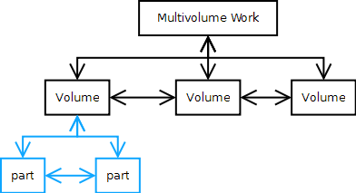

Figure 1 Multilevel description of multivolume works

Another possible hierarchy consists of the semantic units (e.g. chapter, article, issues, parts, volumes, supplements etc.) of the same book.

These “basic” hierarchies require the definition of horizontal and vertical relationships between the different levels of the tree. Vertical relationships express a part-whole relationship between ProvidedCHOs; horizontal relationships order the parts of a resource in a sequence (as given for instance by the consecutive numbering of the parts).

Note that the hierarchy described at the ProvidedCHO level might be very different from the hierarchy described for the digital representation of the same “real” objects (see Figure 2 below). Also, some hierarchical nodes resulting from a systematic analysis of a ProvidedCHO may not link to a digital resource, if the corresponding object has not been individually digitized. I.e. the structure of the object may not fully map to the provided digital representation. We will discuss such cases in more detail in section 4.
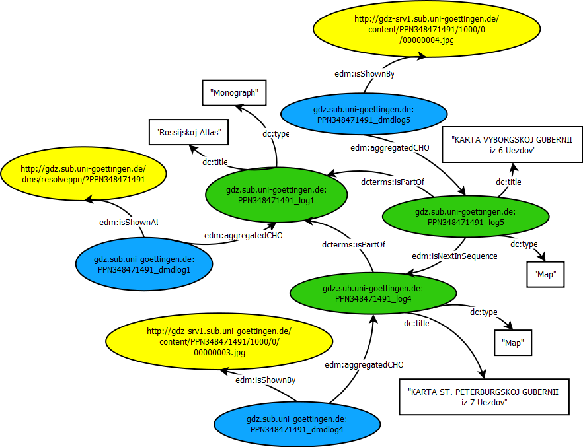

Figure 2 Example where the semantic structure and the physical structure on the child level of the hierarchy are one to one (xml source data for this diagram is available in annex 2)

It should be noted that just because a provided CHO is in a hierarchy, it does not mean that all parts (or containers) should be provided CHOs (and therefore search entries) for Europeana. This Task Force assumes that the Data Provider makes the initial choice on the granularity of the description. We foresee however that some hierarchical analyses are much more desirable than others: a “semantic” hierarchy such as the one mentioned above is clearly preferred over a “physical” hierarchy representing a book’s page structure, where every page is represented as a series of individual objects. This Task Force would in fact recommend avoiding such hierarchies, unless they happen to match with a more fundamental analysis, e.g. when a page in a manuscript includes an illumination worth presenting as a separate cultural object. These choices are related to the recommendations Europeana gives in its content strategy [ContentStrategy].
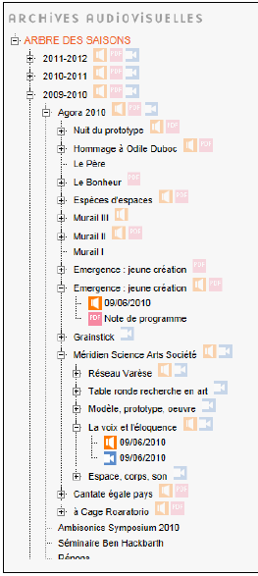

Hierarchies of contextual resources
Related case study: Hierarchical representation of event-related documents.

Cultural heritage objects can also be described within a context which can be modelled into places, agents and events. These contextual entities are in the EDM context defined as NonInformationResources [EDMdefinition] and can be also defined as hierarchies.

For instance, the example on the side shows a hierarchy of events and their related “traces” (sound recordings, program notes…). La voix et l’éloquence event is part of a larger event, Méridien Science Arts Société (which had other "sub"-events), itself part of the Agora 2010 event (a festival composed of many other events). Anyone accessing directly a recording down that hierarchy can choose to access other "nearby" recordings. The “grand-parent” event, “Agora 2010”, has a PDF attached to it, which actually includes the description of all descendents, including this one. The ability of navigating in the hierarchy is crucial in this case.

Figure 3 Hierarchy of events

Hierarchical structures in Archives
Related case studies: Hierarchical objects in the context of the HOPE project, The Montiano family archive, Hierarchies in archival descriptions.

Similar to the libraries, the archives domain uses the “hierarchical model [with regard to] the levels of arrangement for the fonds and its constituent parts. There are levels of description, with differing degrees of detail, appropriate to each level of arrangement. [...] The fonds forms the broadest level of description; the parts form subsequent levels, whose description is often only meaningful when seen in the context of the description of the whole of the fonds. Thus, there may be a fonds-level description, a series-level description, a file-level description and/or an item-level description. Intermediate levels, such as a sub-fonds or sub-series, may be expected. Each of these levels may be further subdivided according to the complexity of the administrative structure and/or functions of the organization which generated the archival material and the organization of the material.” [ISAD(G)]

While the vertical relation between upper and lower levels within an archival fonds (represented in a finding aid) might be more obvious following this model, there also are horizontal relationships between units of the archival description on the same level resulting from a common process of creation and/or administration of these units in their original context.

Archives distinguish three main components:
- Collection: ‘’A set of items with one or more common factors, such as material type, author, publisher, provenance, and/or subject’’.
[Source: HOPE (http://igwiki.peoplesheritage.eu/index.php/Glossary#Collection)]
- Level of Description: “Level of granularity of a Descriptive Unit that is part of an hierarchical description”. The designation of the level is generally specific to the collection domain. (E.g. for archival collections, this might include fonds, series, files, and items, while for library collections, series, titles, and issues.). The project HOPE for instance does not limit the number and type of Levels of Description and can also support idiosyncratic descriptive levels.
[Source: HOPE (http://igwiki.peoplesheritage.eu/index.php/Glossary#Level_of_Description)]
- Archival Finding Aid: “Descriptive Metadata on the records composing an archival collection”. The Archival Finding Aid is generally hierarchical, describing the collection from general to specific, starting with the whole then proceeding to the components (fonds, series, folders, and items).
[Source: HOPE (http://igwiki.peoplesheritage.eu/index.php/Glossary#Archival_Finding_Aid)]

In this kind of hierarchy the parent and children objects are not of the same type.
Independently of the description of the items, their regrouping in upper levels such as fonds or collection may be hierarchically organised (in this case each individual level can be a part of a whole and form an extendable hierarchy of the subset-superset type).
In other cases each individual item will be considered as a member of a whole without being hierarchically connected to other levels other than the parent entity. Objects within a collection or a fonds are related to this collection or fonds by a membership relation.

This situation applies quite strictly to archives where the starting point is a collection comprising different types of items that may not be organised in a hierarchical relationship as shown in Figure 4.

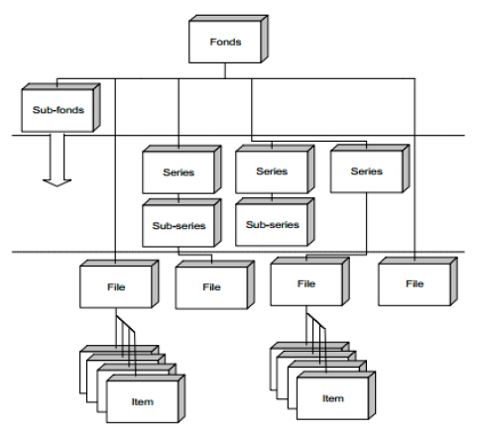

Figure 4 ISAD(G) Model of the levels of arrangement of a fonds

Descriptions of the metadata of fonds or collections reflect their hierarchical structure. There are descriptions on every level. Metadata are defined at the top of the structure, then descend to the lower levels, thus describing the fonds or collection from the general to the specific. However every level may not have digital representations attached to it. Each described unit must identify its own hierarchical level, and identify its next higher unit of description (‘parent’). Information relevant to multiple levels must only be given at the highest appropriate level, and should not be repeated on a lower level. Challenges related to information propagation are further discussed in section 4.

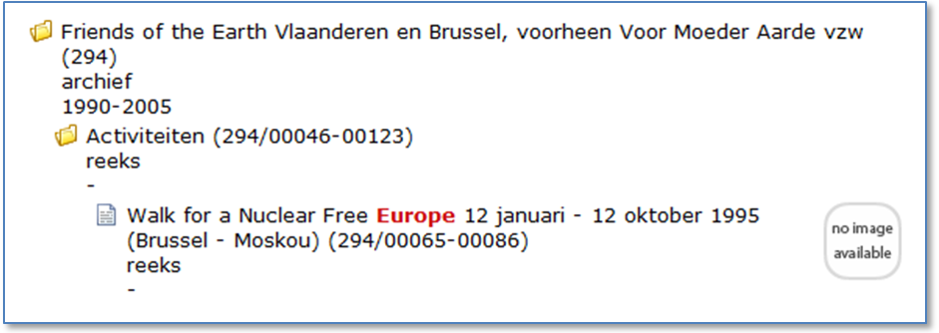
Figure 5 Hierarchical representation of archival metadata (Amsab-Institute of Social History)

Other hierarchical structures - deemed out-of-scope
The group doesn’t consider the following structures as typically hierarchical as described in 3.1 and has declared them out of scope for this report.

“Typical” collections
This includes sets grouped by a curator for an exhibition or archaeology sets (coins from a same hoard). The different units composing a collection have the same importance and are related to the main collection entity as its members. The different units are grouped in one container - the collection - and are related to each other in a one-level relationship. This member relationship functions differently from the (sub) part-whole relationship presented in other cases.

FRBR-like networks
FRBR relationships like “derivation” [FRBR] can appear next to part-whole relations to provide further context on objects. But these fall beyond the scope of plain hierarchical relationships as considered by this Task Force.

Thematical collections with hierarchical objects
Related case studies: Europeana 1914-1918, Israeli artist biographies.

In some situations, different types of object co-exist in a collection. Some of the individual objects could be modelled as hierarchical objects which may enhance the data, but overall, they still do not represent a real hierarchy.

This scenario includes two orthogonal cases:
- collection membership: as said previously, we do not directly consider the collection network as a true hierarchy
- typical hierarchical objects (the second level), which are already treated above.

The project Europeana 1914-1918 gathers collections of contributions from members of the public who bring in memorabilia of various kinds to be digitised. The story behind the items is recorded, the items digitised and metadata created. In this case each contribution associates together one metadata record, one story, one or more items and one or more digitised files (see Figure 6). In this case each individual component is a member of a contribution. The relationship between them is more of an association type than a hierarchical one.
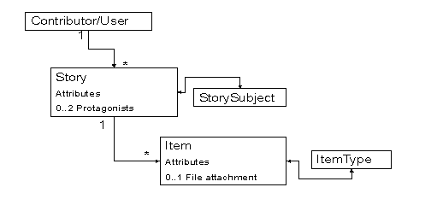
Figure 6 Model to represent contributions to Europeana 1914-1918

Another scenario, Figure 7 below shows an archive of artist files containing also objects produced by each artist. The various relationships between the entities are interesting but are not hierarchical per se. However building a hierarchy for some of these entities may improve the contextualisation of the individual data elements.

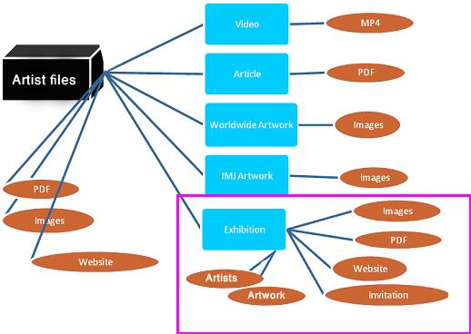

Figure 7 The artist files collection from The Information Center for Israeli Art, The Israel Museum, Jerusalem (IMJ)

For instance starting from the exhibition node it could be possible to organise the artwork created by an artist that participated in an exhibition. In the Figure 8 below, the exhibition node is organised as a collection containing hierarchical objects. The single exhibitions are regrouped into a fonds (Exhibitions 2010-2015) related by a subset-superset relationship. In this case the example becomes of the type of hierarchies described in section 3.2.

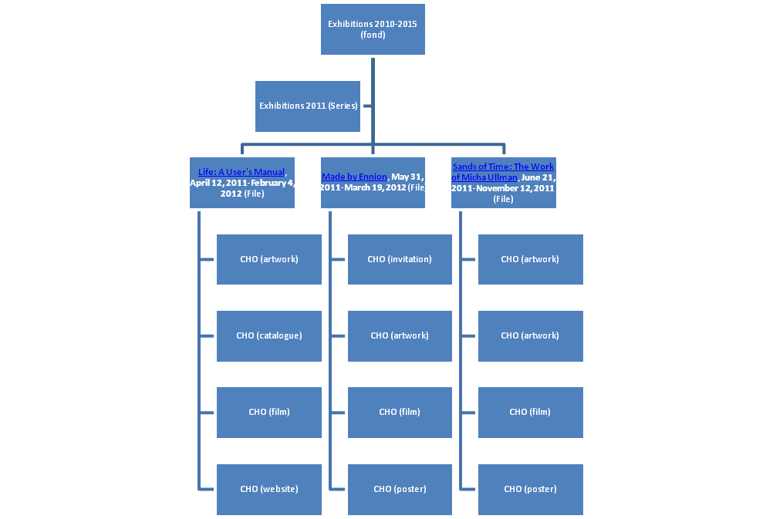
Figure 8 Representation of the exhibition node described in Figure 6 as a hierarchy of exhibitions

Representing hierarchies using the Europeana data model – solutions / patterns / practices

What can be included in hierarchies?
EDM allows the representation of hierarchies for different classes:
- Provided Cultural Heritage Objects (edm:ProvidedCHO)
- Web resources (edm:WebResource)
- “Contextual” resources (for instance edm:Agent, edm:Place, edm:TimeSpan, edm:Concept and edm:Event).

Within the limits of the relevance for Europeana [ContentStrategy] and the availability of metadata for every level of description, a Data Provider is free to decide the level of granularity of the description and the EDM classes the hierarchy concerns.

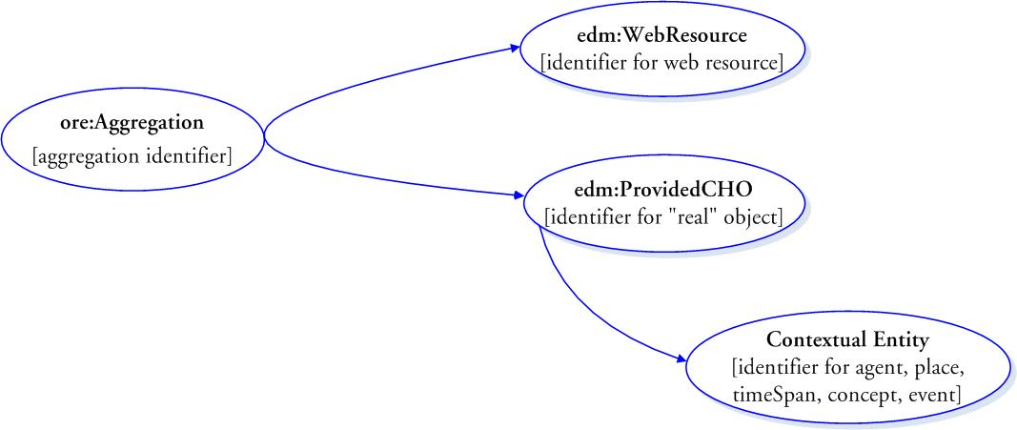
Figure 9 ”Anchor classes” for hierarchies in EDM

Provided Cultural Heritage Objects

The first type of entity which can be included in a hierarchy is the Cultural Heritage Object (CHO), described using the class edm:ProvidedCHO. In this case, the hierarchy focuses on the description of the semantic structure of the object. This level is likely to be the one for which there is the most descriptive metadata.

EDM allows for the representation of the horizontal and vertical relationships between the different levels constituting an object.
Vertical relationships between a whole ProvidedCHO and its parts can be expressed with two specific properties:
- The has-part relation (dcterms:hasPart property) which represents a top-down relation:
- The is-part-of relation (dcterms:isPartOf property) which represents a bottom-up relation.
These types of relationships allow the navigation from a “whole” to a specific part.

Property | Note
dcterms:isPartOf | A resource in which the CHO is physically or logically included. For that purpose it will be necessary to supply an identifier as the value.
dcterms:hasPart | A resource that is included either physically or logically in the CHO.

The horizontal relationships between the parts of a resource (as given for instance by the consecutive numbering of the parts or by pagination) can be expressed with the is-next-in- sequence-to property (edm:isNextInSequence). This property allows the ordering of parts. Note the direction: edm:isNextInSequence relates a part in a sequence with the part immediately preceding it (e.g. issue 3 is the next in sequence to 2).

Property | Note
edm:isNextInSequence | The identifier of the preceding object where both objects are part of the same overall resource. Note that EDM guarantees the uniqueness of the edm:IsNextInSequence property.

As said in section 3.1, the Task Force assumes that the Data Provider makes the initial choice on the granularity of the description. But it is not because a provided CHO is in a hierarchy that all parts (or containers) of it should be provided CHOs (and therefore search entries) for Europeana.

The example below shows a hierarchy of ProvidedCHO as described by the Cité de la musique. A concert recording is documented as a hierarchy of records.
The first, top level record describes the "concert". It contains general information about the recording of the concert itself, such as title, date, location and the most important performers and composers. The other records describe the "constituents" of the concert, i.e. the musical works performed during the concert. Each of these constituent, situated at a lower level of the hierarchy, contains detailed information about the performed musical works (for instance the complete list of performers). If needed, each of the performed musical work record may also have constituent records, such as specific parts in a symphony.

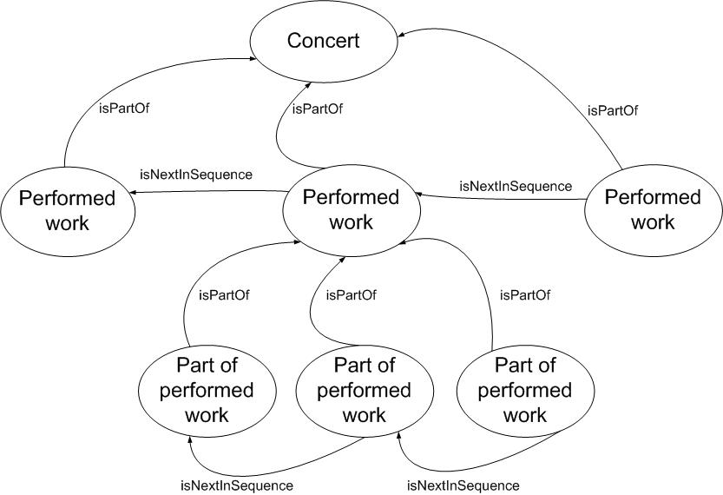

Figure 10 Properties needed to represent a concert recording hierarchy

There are situations where one object could take part in two different hierarchies. For instance, in the library domain a monograph in a series could also be an issue of a journal. Such situations can be represented in EDM. In this example the monograph would have two parents, as represented with two outgoing isPartOf links; one linking to the issue and one linking to the series. Two sets of edm:isNextInSequence statements would represent the order within the two sets of parts of the two parents, each defined as the entities that have this parent as a common dcterms:isPartOf reference.

Similar situations could also appear in the archives domain, e.g. when archival records document administrative processes in different departments of a ministry (read: the creator) and therefore are referenced within the hierarchical groups of both of these departments. Or when an archival fonds has been reorganised and divided due to current administrative structures and is now described in finding aids from two different archival institutions.

The Task Force therefore recommends making edm:isNextInSequence and dcterms:isPartOf repeatable.

It should be noted however that such situations may raise issues when retrieving the objects within a search interface.

Example of a hierarchy of ProvidedCHOs
To finish this section on creating a hierarchy of ProvidedCHOs this example shows how the various parts and sub-parts can be linked.

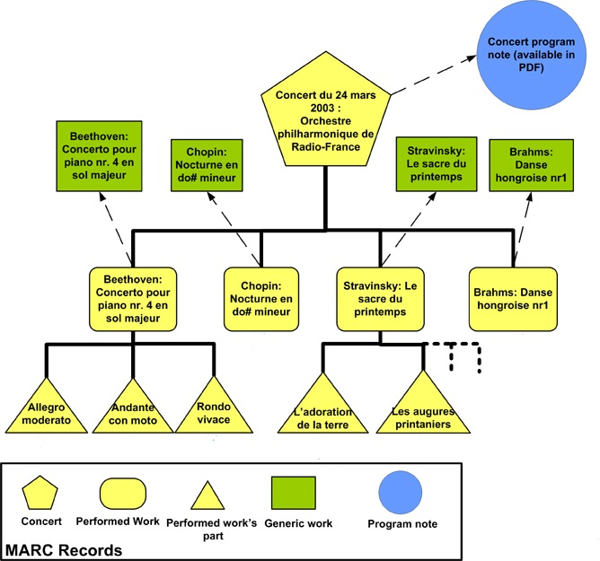
Figure 11 Full example of a hierarchy of ProvidedCHOs

<edm:ProvidedCHO rdf:about="#0079847">
<dc:title xml:lang="fr">Orchestre philharmonique de Radio-France - concert enregistré à la Cité de la musique le lundi 24 mars 2003 (Salle des concerts)</dc:title>
<dcterms:hasPart rdf:resource="#0415432"/>
<dcterms:hasPart rdf:resource="#0415433"/>
<dcterms:hasPart rdf:resource="#0415434"/>
<dcterms:hasPart rdf:resource="#0415435"/>
<edm:type>SOUND</edm:type>
</edm:ProvidedCHO>
<ore:Aggregation rdf:about="http://mediatheque.cite-musique.fr/masc/?url=displayNotice.asp?ID=0079847">
<edm:aggregatedCHO rdf:resource="#0079847"/>
</ore:Aggregation>
<edm:ProvidedCHO rdf:about="#0415432">
<dc:title xml:lang="fr">Concerto pour piano nr.4 en sol majeur Op.58</dc:title>
<dcterms:hasPart rdf:resource="http://mediatheque.cite-musique.fr/masc/?url=displayNotice.asp?ID=0416807"/>
<dcterms:hasPart rdf:resource="http://mediatheque.cite-musique.fr/masc/?url=displayNotice.asp?ID=0416808"/>
<dcterms:hasPart rdf:resource="http://mediatheque.cite-musique.fr/masc/?url=displayNotice.asp?ID=0416809"/>
<dcterms:isPartOf rdf:resource="#0079847"/>
<edm:isNextInSequence rdf:resource="#0415433"/>
</edm:ProvidedCHO>
<ore:Aggregation rdf:about="http://mediatheque.cite-musique.fr/masc/?url=displayNotice.asp?ID=0415432">
<edm:aggregatedCHO rdf:resource="#0415432"/>
</ore:Aggregation>
<edm:ProvidedCHO rdf:about="#0415433" >
<dc:title xml:lang="fr">Nocturne en do# mineur KK IVa Nr.16 (Rappel)</dc:title>
<dcterms:isPartOf rdf:resource="#0079847"/>
<edm:isNextInSequence rdf:resource="#0415434"/>
<edm:type>SOUND</edm:type>
</edm:ProvidedCHO>
<ore:Aggregation rdf:about="http://mediatheque.cite-musique.fr/masc/?url=displayNotice.asp?ID=0415433">
<edm:aggregatedCHO rdf:resource="#0415433"/>
</ore:Aggregation>
<edm:ProvidedCHO rdf:about="#0415434">
<dc:title xml:lang="fr">Le Sacre du printemps</dc:title>
<dcterms:hasPart rdf:resource="http://mediatheque.cite-musique.fr/masc/?url=displayNotice.asp?ID=0416810"/>
<dcterms:isPartOf rdf:resource="#0079847"/>
<edm:isNextInSequence rdf:resource="#0415435"/>
<edm:type>SOUND</edm:type>
</edm:ProvidedCHO>
<ore:Aggregation rdf:about="http://mediatheque.cite-musique.fr/masc/?url=displayNotice.asp?ID=0415434">
<edm:aggregatedCHO rdf:resource="#0415434"/>
</ore:Aggregation>
<edm:ProvidedCHO rdf:about="#0415435">
<dc:title xml:lang="fr">Danse hongroise nr.1</dc:title>
<dcterms:isPartOf rdf:resource="#0079847"/>
</edm:ProvidedCHO>
<ore:Aggregation rdf:about="http://mediatheque.cite-musique.fr/masc/?url=displayNotice.asp?ID=0415435">
<edm:aggregatedCHO rdf:resource="#0415435"/>
</ore:Aggregation>

Web Resources

EDM also enables representing hierarchies of the digitised representations of a ProvidedCHO using the class edm:WebResource. This can be useful in cases such as a concert, when a provider wants to give direct access to a specific part of the audio or video recording file.

In some situations it is possible to model a hierarchy both using the ProvidedCHO and WebResource classes, i.e. have a hierarchy of provided objects that have digital representations that are themselves hierarchically ordered. But a hierarchy for WebResource is not mandatory if the corresponding ProvidedCHOs are already hierarchically ordered. In fact it is not optimal to duplicate these two hierarchies since there may not be a one-to-one correspondence between the nodes of the ProvidedCHO hierarchy and the nodes of the WebResource hierarchy.

This could be due to digitisation practices and constraints: for example, a book may not be digitised in a way that is an exact match with its original nature, or a single piece of music may be divided between two audio file for reasons of size. There may also be Intellectual Property Rights (IPR) reasons: for example, part of a concert may have to be excluded from the concert video if permission has not been obtained from the composer or performers. Section 4.2 goes into more detail about handling missing parts.

Secondly, sometimes ProvidedCHO metadata may be missing for one level of WebResources. This situation is further explained in section 4.2 of this report. Note this case should be left to situations where there is no metadata on the "sub-objects" that correspond to the "sub-views". It is better to have hierarchies at the ProvidedCHO level if there is enough data: hierarchies of web resources cannot act as substitute for “real” objects.

The following properties are currently available in EDM for representing hierarchies of edm:WebResource:

Property | Note
dcterms:hasPart | A resource that is included either physically or logically in the web resource.
edm:isNextInSequence | Where one web resource has several parts, shown by multiple instances of the edm:hasView property on the ore:Aggregation, then this property can be used to show the sequence of the objects.

The following property is currently not available in EDM for representing hierarchies of edm:WebResource but is recommended by this Task Force.

dcterms:isPartOf | A resource in which the Web resource is physically or logically included. For that purpose it will be necessary to supply an identifier as the value.

Example of a hierarchy of WebResources

We refer to the next section for concrete examples on web resource hierarchies (which also show lack of synchronisation between ProvidedCHO and WebResource hierarchies), but a typical diagram is shown below.

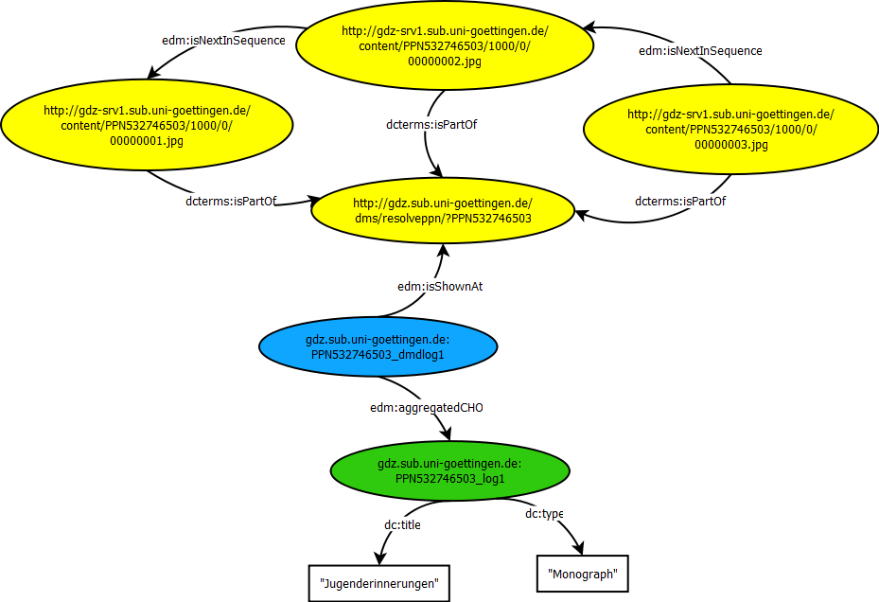
Figure 12 Example of hierarchies in WebResources (xml source data for this diagram is available in annex 3).

Contextual resources

As described earlier, the Task Force has identified the need of representing hierarchies for contextual entities. This requirement is important to allow a good navigation from one entity to another. EDM contextual entities fall mostly within the following types of what is referred to as “non-information resources” in the Web terminology: edm:Agent, edm:Place, edm:TimeSpan, edm:Concept, edm:Event and edm:PhysicalThing.

Agent (edm:Agent)

Hierarchical links can be used for two kinds of agents: corporate bodies and families. For example the concert hall-Salle Pleyel in Paris is owned by Cité de la musique.

The Task Force recommends the implementation of the following properties for the agent:

Property | Note
dcterms:hasPart | identifier of an agent that is part of the agent being described.
dcterms:isPartOf | identifier of an agent that the described agent is part of.

Place (edm:Place)

The following properties are already available in EDM.

Property | Note
dcterms:hasPart | identifier of a place that is part of the place being described.
dcterms:isPartOf | identifier of a place that the described place is part of.

The Task Force identified cases where it might be interesting to represent the sequence between different places entities e.g. the (historical) layers of the city of Troy. We therefore recommend the use of edm:isNextInSequence for the place entity. In such a situation the Task Force considers the ontological commitment as minimal.

The following property is currently not available in EDM for edm:Place and should be added:

edm:isNextInSequence | The identifier of the preceding entity where both entities are part of the same overall resource.

Timespan or Period (edm:TimeSpan)

The following properties are already available in EDM.

Property | Note
dcterms:hasPart | identifier of a timespan which is part of the described timespan .
dcterms:isPartOf | identifier of a timespan of which the described timespan is a part.

The following property is currently not available in EDM for edm:TimeSpan and should be added:

edm:isNextInSequence | The identifier of the preceding entity where both entities are part of the same overall resource.

Concept (skos:Concept)

The following properties are already available in EDM.

Property | Note
skos:broader | identifier of a broader concept in the same thesaurus or controlled vocabulary.
skos:narrower | identifier of a narrower concept

Event (edm:Event)

dcterms:hasPart | reference (to an Event)
dcterms:isPartOf | reference (to an Event)

The following property is currently not available in EDM for edm:Event and should be added:

edm:isNextInSequence | The identifier of the preceding entity where both entities are part of the same overall resource.

Figure 13 below represents a hierarchy of concert events associated to their individual recordings. An event like a concert may be repeated on several dates. It will still be described by a single metadata record, to which all the traces – e.g. the single program note (as it applies for each performance) and the distinct recordings (one on each date) will be attached. Metadata records for any event node (inner or leaf) contain hyperlinks to the parent, to the children (if any) and to the related digital documents.

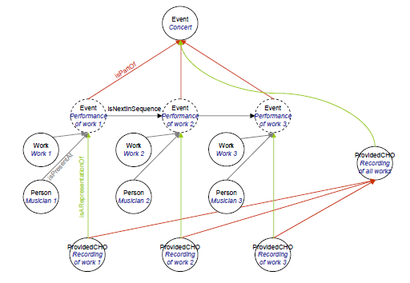
Figure 13 Hierarchy of events

EDM features another class of contextual entities: Physical Things (edm:PhysicalThing). This class gathers “cultural heritage objects known to Europeana to be physical things (such as Mona Lisa) as well as all physical things Europeana refers to in the descriptions of cultural heritage objects (such as the Rosetta Stone)”. PhysicalThing is not yet proposed for ingestion in Europeana, but as been already defined with the necessary properties (see http://europeanalabs.eu/wiki/EDMObjectTemplatesProviders#edm:PhysicalThing). This class could be used for hierarchical objects in the situation where a ProvidedCHO does not have any digital representation and exists for Europeana only through its metadata.
Other contextual entities are not yet foreseen, as Europeana won’t accept any arbitrary sub-class of edm:NonInformationResource or edm:InformationResource.

Representing missing parts
Parts missing metadata

There is no “mandatory level” in an EDM hierarchy. As already hinted, some levels may be omitted. This is especially the case when a level has not been described in the original metadata model. Or in the archives domain, where not every level within a hierarchy of an archival fonds may have digital representations attached to it. By default, these parts cannot be described as ProvidedCHO. Data Providers might decide to not provide the CHO at all. If the missing node is a leaf of the tree, the potential ProvidedCHO may safely be discarded. However this is harder to do when the missing ProvidedCHO is an inner node (i.e. it has children). Moving it out of the hierarchy indeed implies losing of information about the context of the children CHOs.

To alleviate the issue, it should be possible to supply the CHO to Europeana as a contextual resource, using a suitable EDM types (e.g. skos:Concept could be used if it is an abstract work, edm:PhysicalThing if it is a tangible object).

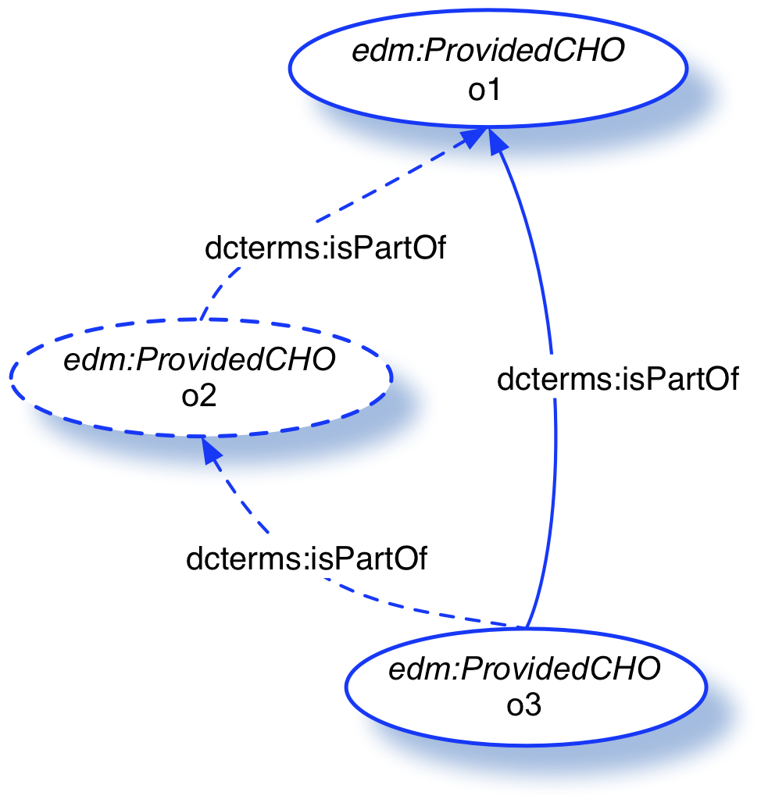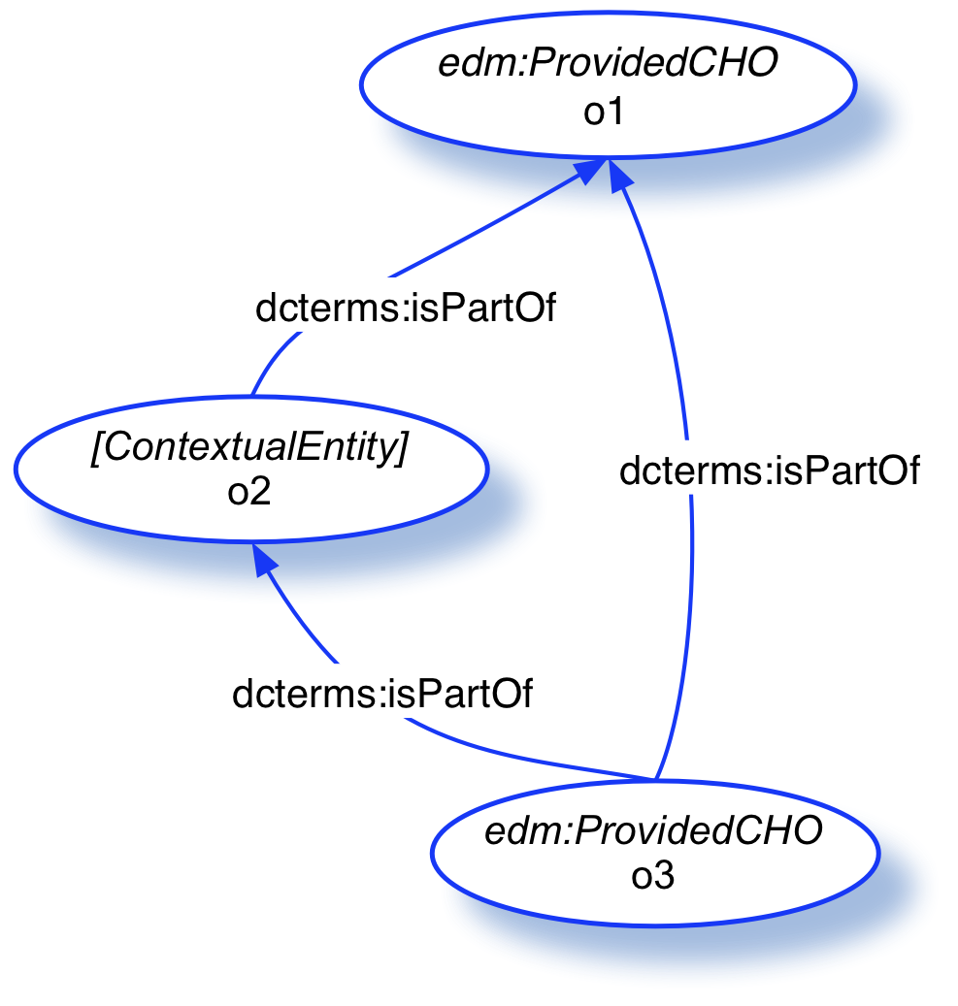
Figure 14 In the first case the missing ProvidedCHO is not represented. In the second case the missing ProvidedCHO is represented as a contextual entity.

This second option brings however a case of “mixed” hierarchy (ProvidedCHOs and contextual resources) which will raise challenges to implementers of search and display interfaces, which may not be tackled soon. Also, the contextual entity may be almost void of metadata, bringing to the end user (or a data consuming service) the only benefit of a well-balanced hierarchy. Further, it may be difficult to assign it an EDM type in the first place. The type of contextual resource matching the CHO at hand may also not be implemented in Europeana at the time of ingestion. Data Providers may thus prefer to invest time “re-working” their hierarchy in such case.

Finally, it is possible to provide a ProvidedCHO with a “more artificial” digital representation, e. g. an HTML landing page describing the object in detail, provided using edm:isShownAt. This would technically allow the object to be ingested in Europeana, but remains to be validated along Europeana’s (and the providers’) criteria for judging which digital representations are relevant to show to users in the context of search engines or other applications.

Another issue is how to reflect sequence information (if any) at the level of the missing CHO. In a first approach we need then to use edm:isNextInSequence to indicate that say, the third part of a concert “follows” the first part, in case the second part could not be represented (see Figure 15 below).

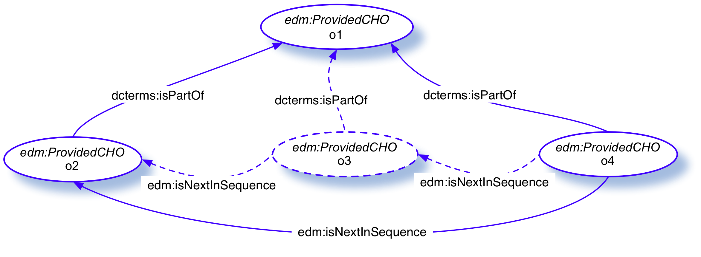
Figure 15 Representation of a sequence between two non-consecutive CHO when one is missing.

This solution is simple to implement, and compatible with Europeana’s first EDM implementations. But it may be judged a borderline usage (semantically speaking) of edm:isNextInSequence by Data Providers and consumers alike.

An alternative is to keep the object in the hierarchy, but representing it as a contextual entity, using for example the class edm:PhysicalThing:

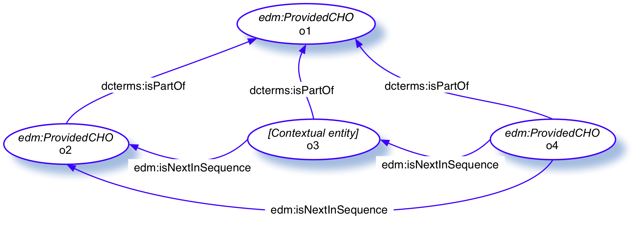
Figure 16 Alternate solution where the missing ProvidedCHO is represented as a contextual entity.

This however raises some of the “mixed hierarchy” issues mentioned above. This solution is also more adequate and semantically correct when the contextual entity and the ProvidedCHO are of the same type (as defined by the Data Provider).

A question that has finally to be addressed when a ProvidedCHO is removed, is the fate of its associated digital representations, if it had any and if they are judged crucial by the provider. It is always technically possible to attach the concerned WebResources to the above level. A first, preferred option—if these web resources are compatible with the needed statements—is to attach a hierarchy of web resources to the parent of the missing object via its corresponding ore:Aggregation:

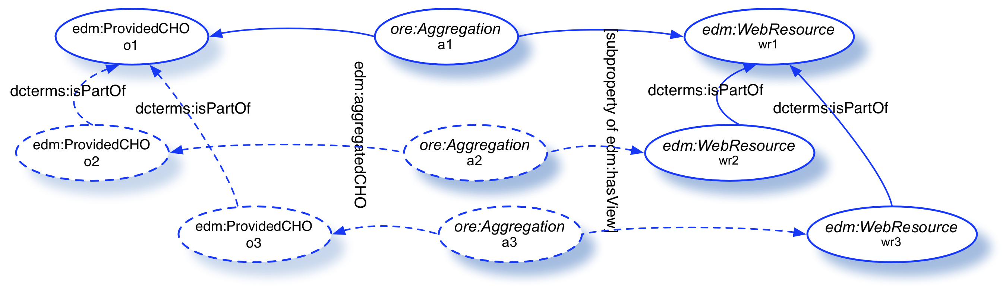
Figure 17 linking a hierarchy of WebResources to the parent of the missing object.

The second option is to directly attach the representations of the parts onto the Aggregation of the parent CHO:
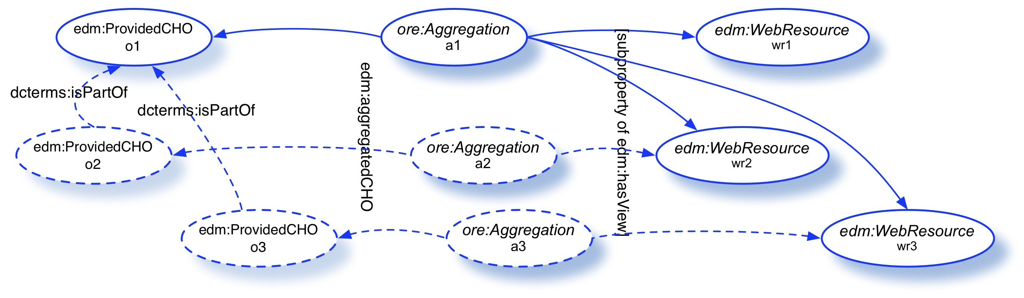
Figure 18 linking directly the WebResources to the ore:Aggregation of the missing objects’ parent.

This option is not preferred as it would present the users representations of different (if related) objects without any further information.

Parts missing digital representations

As mentioned in section 4.1.2, a potential ProvidedCHO may not have a dedicated digital representation (represented in EDM using edm:WebResource). This can result from digitizing, archiving or publication practices. For example, after having visualized the recording of a concert, the performers may not like their performance of one specific work. The online publication of the concert would then exclude a representation of the specific work. Alternatively, considering a concert - an event during which different pieces have been played - we might have information on the performance of a work but no digital recording of it for licence reasons (See Figure 11).

This raises a crucial issue in the Europeana context, as CHOs that don’t link to a digital resource will not be authorized. As in the above case, if the resource to be removed from the CHO hierarchy is a leaf of the tree, the potential ProvidedCHO may safely be discarded.

But as in the previous case, if the missing ProvidedCHO is an inner node (i.e. it has children which link themselves to digital content) it is more difficult to discard it. “True” provided objects downstream may then lack crucial context data. Here two options suggested for the previous issue may be followed:
- provide a ProvidedCHO with an “artificial” representation (e.g. a landing page using edm:isShownAt) that still allows it to be ingested in Europeana;
- supply the resource to Europeana as a contextual resource, using one of the available EDM classes that match the corresponding CHO.

As already hinted, the first option can be disappointing in terms of user experience. However, the second which brings a case of “mixed” hierarchy (ProvidedCHOs and contextual resources) will as mentioned earlier raise challenges to implementors of search and display interface, which may not be tackled quickly. The type of contextual resource matching the CHO at hand may also not be implemented in Europeana at the time of ingestion.

Parts missing in contextual resources

Conversely to the previous cases, a part may be missing in a hierarchy of resources (e.g. events) that contextualize ProvidedCHOs. Similarly to the above case, the situation will raise more problems if the missing contextual resource is an inner node in the tree. However, such issue cannot be solved easily: such broken context cannot be fixed, and it is in fact expected that the original metadata for other resources in the hierarchy will not mention the missing part other than in informal references—other situations would be inconsistent.

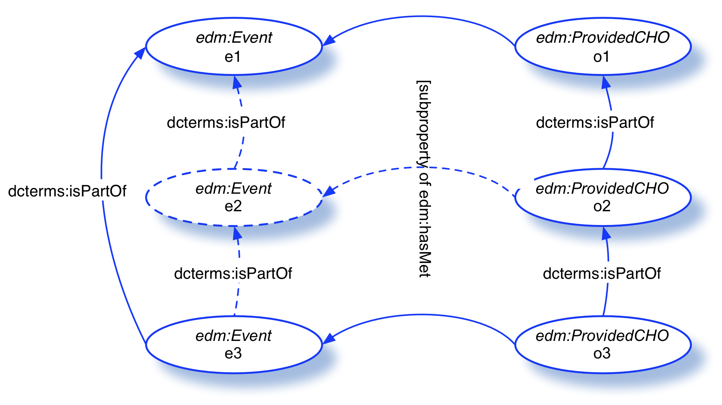
Figure 19 Relationship between a hierarchy of contextual resources and a hierarchy of CHOs in which some levels are missing.

This example shows part of a yearly concert season composed of series of concerts (i.e. concerts thematically related), each one having an associated digital document – the program notes (typically: a PDF describing the single concerts in that series) – and linked to the individual events comprising that series – the concerts, with their associated recordings. The case arises in some archives that while (most of) the recordings are present, some information about intermediate events – e.g. in this example “Concert series 2” – is totally missing. It is still important to be able to represent the full hierarchy of events.

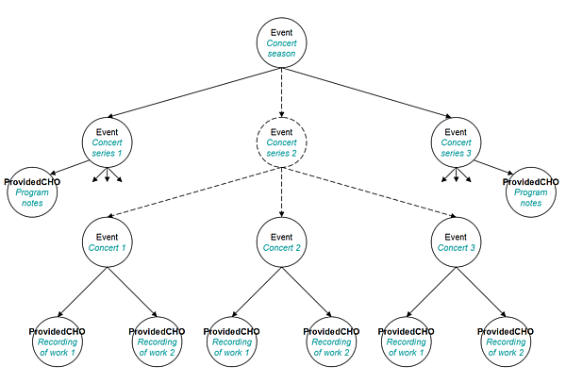
Figure 20 Specific example of a hierarchy of events where some levels are missing.

How to sequence parts in EDM?
As described in the previous sections, sequential relationships are expressed in EDM using the property edm:isNextInSequence. The Task Force foresees sometimes a specific, function-driven usage of this property. Namely, it can be used to describe a sequence in which there are “holes” and which are therefore not contiguous in a situation where all objects would be properly documented and digitized. In such cases, data consumers such as implementers of search and display services still need representations that are actionable, even though they may not be theoretically perfect. This is why we do not forbid such usage of isNextInSequence and leave Data Providers free to decide which sequence is relevant for them and Europeana.
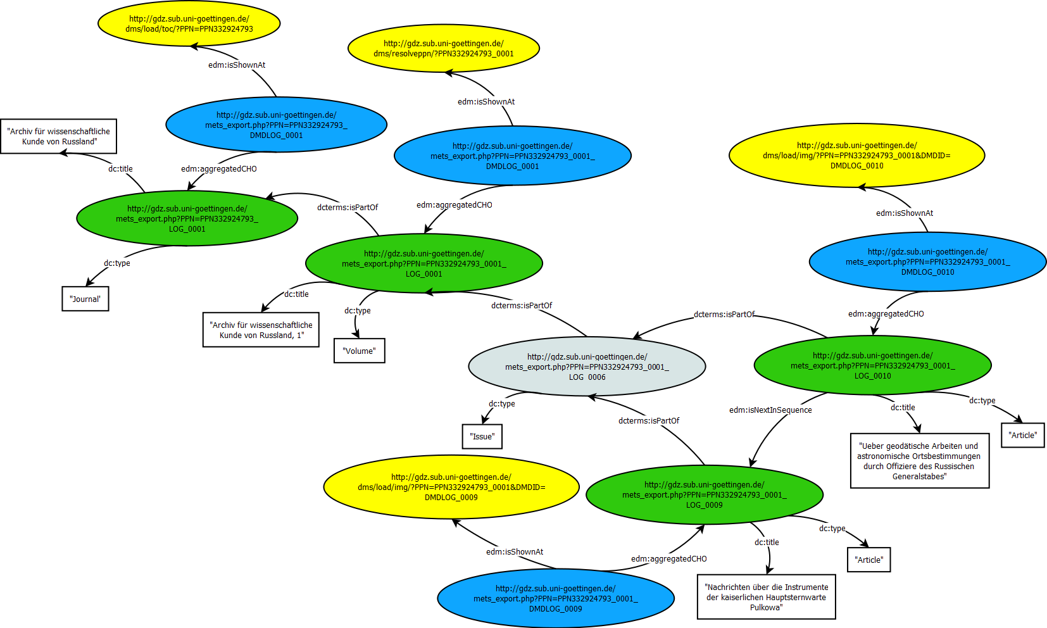
Figure 21 Sequential relationships between ProvidedCHOs (xml source data for this diagram is available in annex 4).

The Task Force has considered the use of the property edm:isSuccessorOf in such situation but as decided to not do it to stay in conformity with the definition of this property. In fact edm:isSuccessorOf should be used to “capture the relation between the continuation of a resource and that resource. This applies to a story, a serial, a journal etc. No content of the successor resource is identical or has a similar form with that of the precursor. The similarity is only in the context, subjects and figures of a plot.”

The creation of the IsNextInSequence relationship might cause some issues, especially when real metadata are lacking. As a matter of fact, this information is highly “implicit”, and can be very often derived using the order of the cataloguing of the sub-parts, or through very “low-level” information such as names of files ( xx_1.wav ; xx_2.wav ; etc.). Even if this information is not available in the data, it could be created during data conversion. edm:isNextIsSequence is therefore not mandatory because of the potential difficulty to produce this information.

Data propagation - inheritance
An important issue when considering hierarchies is the possible propagation of metadata between the different levels. For example, the temporal coverage of an archive fonds may extend to the levels beneath it. The general subject matter of a journal should be also somehow relevant to its articles, and so on.

Some projects have worked on the issue, notably APEnet [APEnet] and HOPE [HOPE].
As an example from the archives domain one can refer to the already mentioned principle in EAD to only provide information applicable to more than one hierarchical level at the highest level in the constituent sequence. That is in case of an archival fonds, which usually is created following the provenance principle (i.e. records created and administered by the same records creator form one archival fonds or subfonds), information about the creator is only given with the top level description, but will not be repeated in all levels following below, including the ones containing the digital object(s).

The conversion tool of the Archives Portal Europe therefore allows the Data Providers to specify, if they want to “physically” inherit information from higher levels to the level containing the digital object when converting from apeEAD (the EAD profile as defined for the use in the Archives Portal Europe) to ESE. This can be done specifically:
- for information on the creator and
- for information the language of the material.
Furthermore it is possible to inherit all relevant information from higher to lower levels in one step.

This Task Force, however, lacked time to discuss these issues at a general level, which could apply across projects.

Further, the issue of data propagation and inheritance can be quite specific to certain application choices. I.e. metadata propagation can be implemented by augmenting a search index or devising some smart hierarchical object display strategies, rather than counting on a provider's copying field values across levels in the metadata. One may argue then that it is less relevant to exchanging metadata, which is core to the Task Force charter, but rather pertains to the level of display or search recommendations that we are going to touch in section 5.

Display/access for hierarchical objects in Europeana
Hierarchical objects offer many challenges when it comes to data modelling; but there are equally important problems for search and display of hierarchies. These questions were not the primary focus of the work of the Task Force. We will therefore stay succinct on the topic and restrain ourselves to the formulation of requirements and display proposals.

Searching hierarchical objects
The search and retrieval of hierarchical objects in an interface such as Europeana rely on various components which face their own challenges. Richness of the descriptions of the different levels, index settings are aspects that may limit the search and retrieval capabilities.

The main requirements to be fulfilled are the following:

- It should be possible to make search queries on the objects contained in a hierarchy
- It should be possible to make search queries in all the levels of descriptions of an object.
- It should be possible to search an object via information on its context.
- A user should be able to find the different objects of a hierarchy. It is important to note that the granularity chosen when modelling the data might induce some issues for an end-user when searching for objects.

Worth to notice, the aforementioned APEnet data conversion tool allows one to find the lower levels of an archival description by their creators in search engines, while not having to repeat explicitly (at metadata creation time) the creator on the fonds’ level of an EAD file onto each of the lower hierarchical levels (except there would be a different creator for certain files or groups of files). We expect a main benefit of exchanging data on hierarchical objects with more precision will be enable implementers of search engines to reproduce such strategies, without having to rely on such work-around by Data Providers.

Presentation of the hierarchies
The main issue when presenting hierarchies is the preservation of the organisation of the hierarchy and the contextual information it contains. When presenting hierarchies, one should make sure that:

- A user should be able to grasp a complex object as a whole and understand the relationships between the different objects which composed the hierarchy.
- An object should be always presented in context (digital representation and descriptive metadata if possible).

In the APEnet example again, the function of the EAD-ESE conversion tool includes the “propagation” of creator information to make this creator visible to Europeana’s users when they view objects at any level of the hierarchy. In addition, it proceeds with concatenating all higher level titles in one element (here: <dcterms:alternative>), so that they can be made available together with the title of the level containing the digital object. This workflow became necessary as – similar to the principle of inheriting information – the title of an archival file is formed within the context of its creation and administration. That is, in the administrative process of public papers e.g. from the “Ministry of Culture” a group of files might have been created including “Correspondence”, which might later on have been further divided into groups like “Correspondence with other ministries”, “Correspondence with political partners”, and “Correspondence with citizens”, which furthermore might have been divided by alphabetical order in files with titles like “A – E”, “F – J”, “K – O”, “P – T”, “U – Z”. While this becomes obvious when being accessed via the hierarchical structure of an archival finding aid, having the single files stripped of its hierarchical context and only showing a title like e.g. “A – E” might not be too helpful for someone consulting this file.

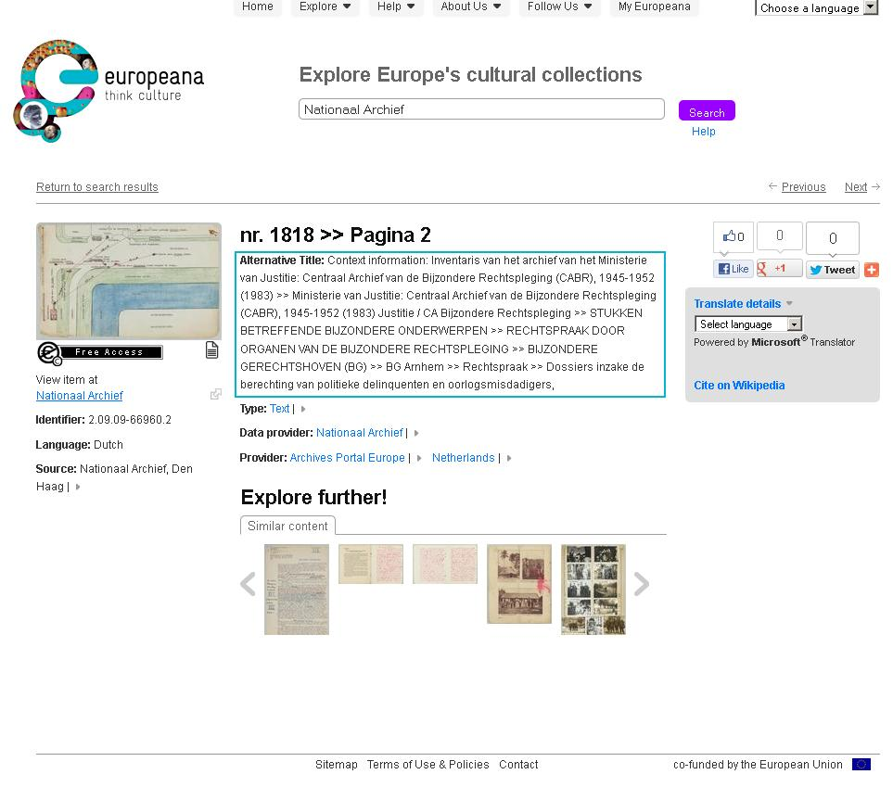
Figure 22 Example of concatenated titles from higher hierarchical levels

The example below shows a way of navigating through textual resources. An end-user would be able to navigate through the resource and still grasp its hierarchical structure.
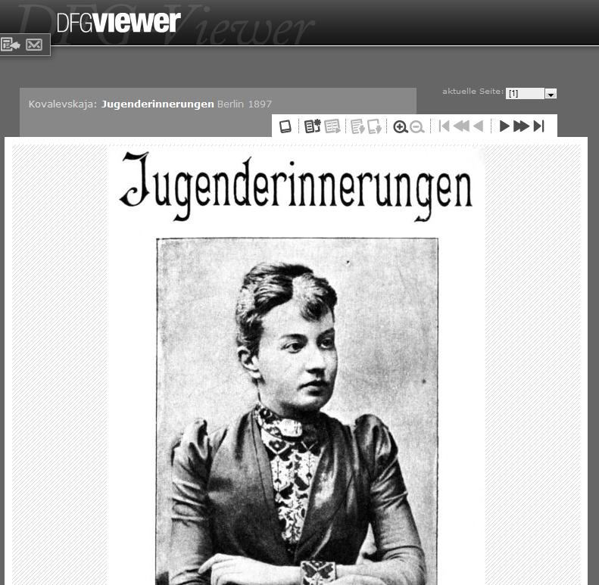
Title of ProvidedCHO
Number of
the page
Browse through
pages
http://dfg-viewer.de/v2/?set[mets]=http%3A%2F%2Fwww.zvdd.de%2Fdms%2Fmetsresolver%2F%3FPPN%3DPPN532746503
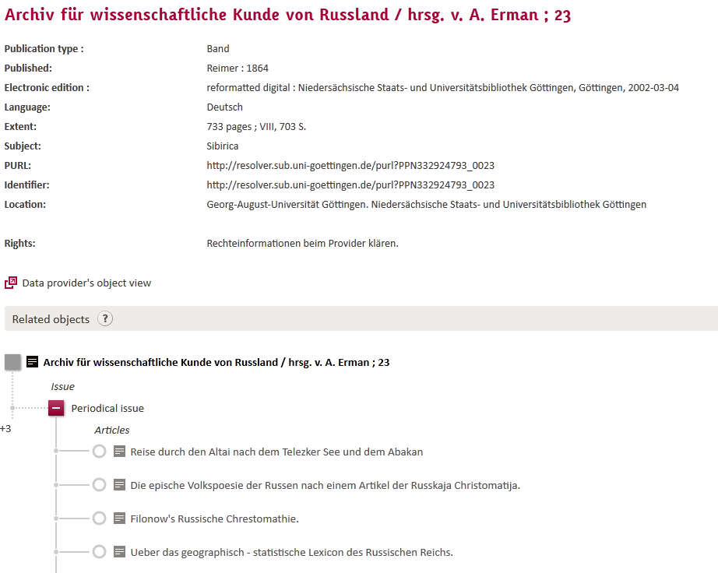
Description of
the Volume
Link to the description of the Article
Issue
Figure 23 Example of navigation through a book by the test environment of the German Digital Library

In order to show the importance of the presentation of hierarchies let us use the example of an audio recording for a concert which is composed, as described in the “Relation” field, of different musical works. The presentation of this concert in Europeana doesn’t allow the user to clearly see that within the same concert several musical works have been played. The “Relation” field is only containing textual information on these different musical works and is not linking directly to them.
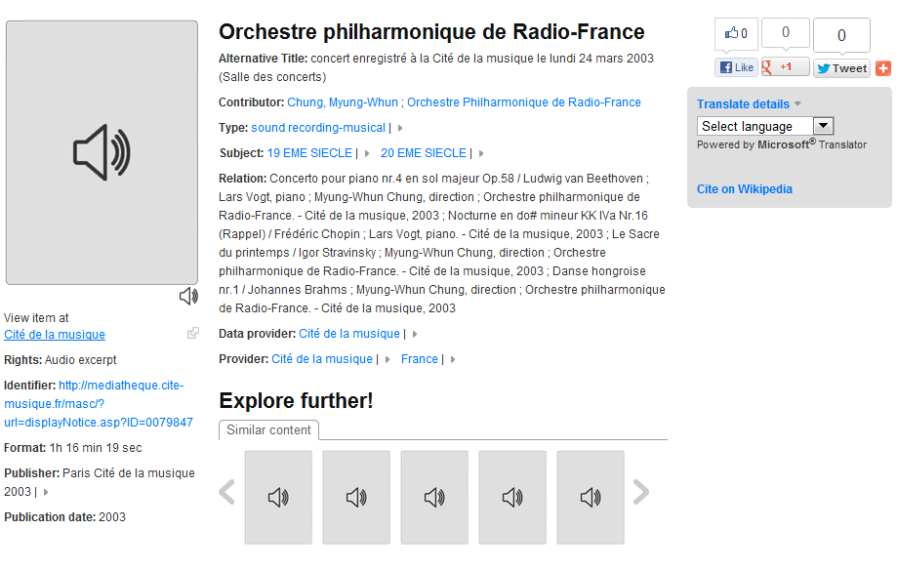
Figure 24 Example of a complex record in Europeana

Figure 25 (below) shows a better solution to represent this concert. The player at the bottom of the record offers a representation of the concert hierarchy. A mouse-over on any of the small cases at the bottom will display the title of the corresponding sub-part.
This player allows users to play a specific part of the concert (clicking one of the concert part will play the specific part)

The dynamic rendering of the player at the bottom of the record is possible if and only if the hierarchical information (isPartOf and isNextInSequence properties) of the concert is part of the metadata.
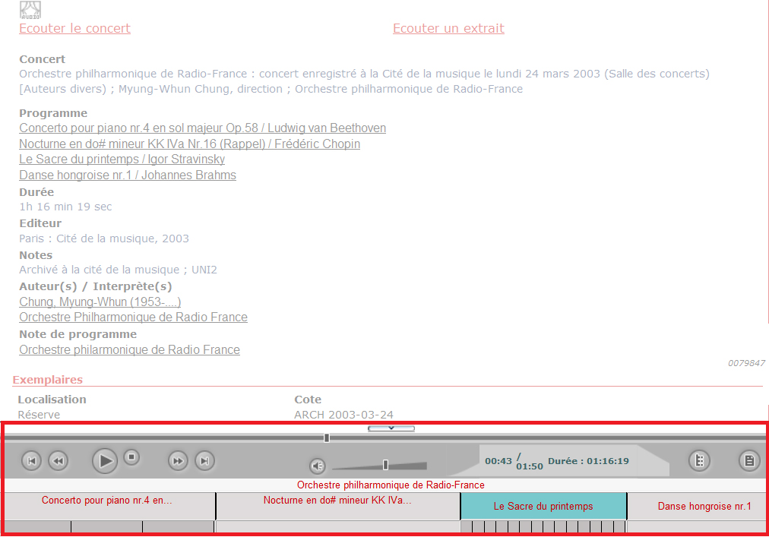
Figure 25 A display example of a concert.

Navigation from one level to another one
As explained in the previous sections on this report, EDM provides many mechanisms to describe the relationships between objects within a hierarchy. The navigation within a search interface will be tightly linked of the definition of these relationships in the data.

- Users should be able to navigate within the tree:
  - from a given object to nearby related objects (siblings, parents…)
  - from upper to lower levels of descriptions
  - from lower to upper levels of descriptions
  - from a hierarchy to another if an object belongs to different hierarchies

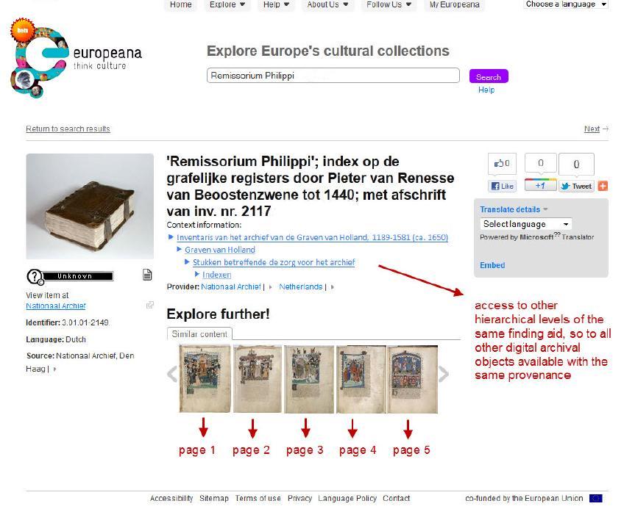
Figure 26 Example of navigation within an archival fonds with hierarchical structure (Mock-up from APEnet Final Interoperability Report [APEnet].

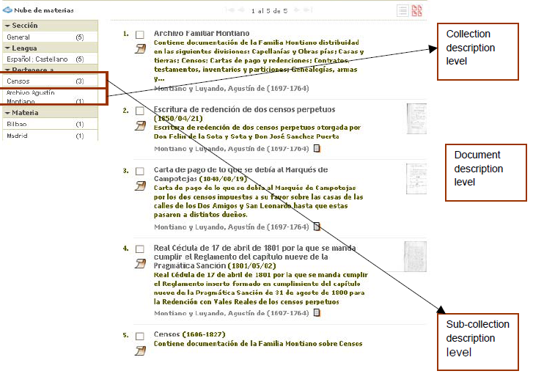
Figure 27 Example of navigation within a collection with hierarchical structure.

Of course a full navigation will also raise questions of usability and clarity for the user.

The type of navigation within the hierarchies will be determined by the choices made by Data Providers when modelling the data. These types of choices matter especially when hierarchies are incomplete (see section 4.2).

The examples below propose a way of navigating within a complex hierarchy of events. This tree allows a direct access to contents which are hidden in folded parts. The red arrows indicate inner nodes to which there is no content attached and for which there is sometimes no other information than the fact that they semantically link related sub-events (the icons next to these nodes are greyed out, so as to indicate that there is digital content somewhere inside the corresponding sub-tree) and allow also navigating by this semantic neighbourhood. In some (other) cases, documents may be attached at that level (i.e. of inner nodes), e.g. programme notes for a whole yearly season or a festival.

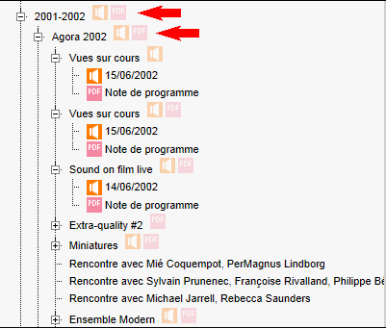
Figure 28 Example of navigation within a tree

In the following example, neighbours of the item and its parents and ancestors are shown. It allows the user accessing either the metadata or the digitised data attached to each of these items.
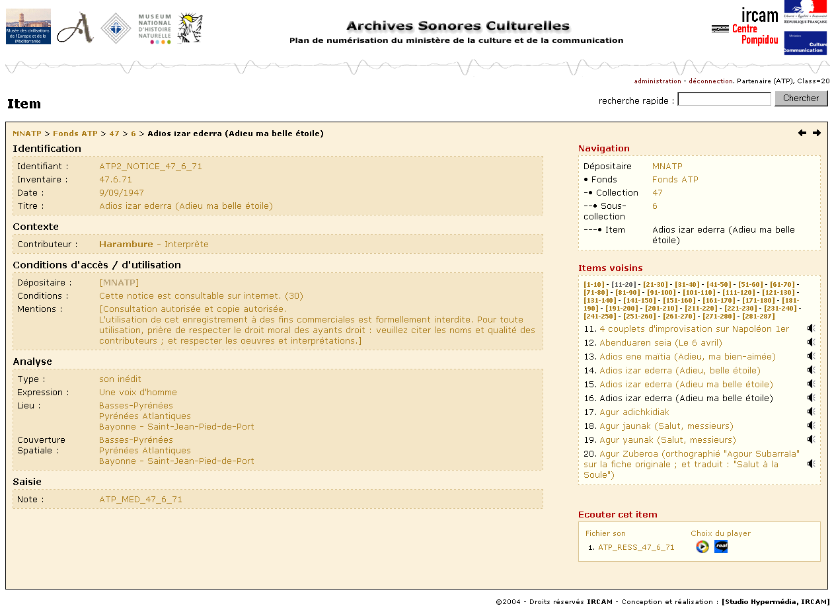
Figure 29 Example of navigation from a given object to nearby related objects (siblings, parents…)

Conclusion
In this report, we have identified the various types of hierarchies that can be found in Culture Heritage objects. For each challenging situation, we have proposed data representation solutions using the Europeana Data Model (EDM). This includes best practices for handling the borderline cases where entities that would be expected in a hierarchy are missing a description or a digital representation. We hope that these recommendations will encourage Data Providers to provide more complex objects to Europeana and therefore will allow Europeana to build new functionalities for its portal.

We have also issued suggestions for updating the EDM model itself: while the existing EDM elements fit the vast majority of cases, some relatively small adjustments would help addressing an even wider range of situations.

Additionally, the Task Force feels that more guidance in terms of content strategy would be helpful for Data Providers willing to contribute complex objects.

Finally, the Task Force has identified a few cases, especially the ones with collections as simple containers of objects, which we felt would be better considered separately. However collections present challenges that are close the ones for hierarchies and we would recommend the creation of a new Task Force to tackle these issues.

The Task Force on hierarchical object that have highlighted various recommendations in this report. These recommendations are addressed to Data Providers wishing to provide complex objects to Europeana; but also to Europeana regarding its implementation of EDM. .

- Granularity of hierarchy description: The Task Force assumes that the Data Provider makes the initial choice on the granularity of the description of hierarchical objects, within the limits of relevance for Europeana. The fact that a provided CHO is in a hierarchy does not mean that all parts should be provided CHOs for Europeana. It is important to note that the granularity chosen when modelling the data might induce some issues for an end-user when searching for objects. Additionally, the Task Force feels that more guidance from Europeana in terms of content strategy would be helpful for providers willing to contribute complex objects.
- Granularity of hierarchy description: The Task Force favours the description of “semantic” hierarchy over the description of hierarchy representing the “physical” structure of a provided CHO (e.g. the book’s page structure vs. say its chapters).
- Sequence vs. succession: the Task Force noticed that the example given for the property edm:isSuccessorOf doesn’t reflect the semantics of the property. Europeana should change it to avoid confusion with the property edm:isNextInSequence.
- EDM properties for ProvidedCHO: The Task Force recommends making edm:isNextInSequence and dcterms:isPartOf repeatable to allow representing that a provided CHO belongs to different hierarchies. Data Providers should however note that this situation may raise display issues when retrieving such objects from a search interface.
- EDM properties for WebResource: The Task Force recommends the implementation of the property dcterms:isPartOf for the edm:WebResource class to allow for a flexible description of a hierarchy of WebResources.
- EDM properties for WebResource: the property dcterms:hasPart should only allow for references as values, when applied to this class of resources.
- EDM properties for contextual resources: We recommend the implementation of dcterms:hasPart and dcterms:isPartOf for the edm:Agent class.
- EDM properties for contextual resources: We recommend the implementation of the property edm:isNextInSequence for the edm:Place, edm:TimeSpan and edm:Event classes in order to support ordered hierarchies of contextual resources.
- Representation of “missing parts”: In order to alleviate the issue of “missing parts” in a hierarchy, the Task Force proposes to supply the CHO to Europeana as a contextual resource.
- Representation of sequences: edm:isNextInSequence should be used to describe a sequence between two resources in a hierarchy. When needed, the Task Force allows for a borderline usage (semantically speaking) of edm:isNextInSequence to indicate a sequence between two non-consecutive resources when the resource in-between is missing.
- Display of hierarchical objects: The ability of navigation in hierarchical object is crucial for the Task Force when displaying hierarchical objects.

References
[APEnet]
Final interoperability report http://www.apenet.eu/images/docs/APEnet_Report_D3.2_WP3_Final_Interoperability_Report.pdf
Interoperability Specifications report
http://www.apenet.eu/images/docs/APEnet_Report_D3.1_WP3_Interoperability_Specifications_Report.pdf
[EuropeanaCase]
Europeana case study: The Minister’s selection by Kennisland: http://www.kennisland.nl/filter/publicaties/europeana-case-study-the-ministers-selection
[RDA]
RDA Draft report 2008, Appendix D section 2.4.1: http://www.rda-jsc.org/rdafulldraft.html
[ContentStrategy]
Europeana Collections and Data Analysis, Strategy and Plan 2012-2014 http://pro.europeana.eu/documents/866067/6e0472f6-da6e-4ac0-93ba-9e3290a66fce
[EDMdefinition]
EDM Definitions at http://pro.europeana.eu/edm-documentation
[ISAD(G)]
ISAD(G), http://www.icacds.org.uk/eng/ISAD(G).pdf
[FRBR]
A EuropeanaTech Task Force works currently on the modelling of FRBR networks in EDM:
http://pro.europeana.eu/network/europeana-tech/-/wiki/Main/Task+Force+EDM+FRBRoo
[HOPE]
The Common HOPE Metadata Structure, including the Harmonisation Specifications
http://www.peoplesheritage.eu/pdf/D2_2_Metadata%20Structure.pdf

Other documentation:
Outcomes of the Hierarchical Display meeting 16 September 2010:
http://pro.europeana.eu/group/europeana-v1.0/documents/-/document_library/view/318819

EDM documentation:
http://pro.europeana.eu/edm-documentation

Annexes
Annexes 2 to 5 and the case studies can be downloaded from the wiki page at http://pro.europeana.eu/network/europeana-tech/-/wiki/Main/Taskforce+on+hierarchical+objects

Annex 1: Hierarchical objects Task Force Charter (see below)

Annex 2: xml source data describing a situation where the semantic structure and the physical structure on the child level of the hierarchy are one to one. (Figure 2 in the report)

Annex 3: xml source data describing hierarchies in WebResources (Figure 12 in the report).

Annex 4: xml source data describing sequential relationships between ProvidedCHOs (Figure 21 in the report).

Annex 5: Cases studies
-Hierarchical description of objects from libraries
-Hierarchical representation of event-related documents
-Hierarchical objects in audiovisual archives
-Hierarchical objects in the context of the HOPE project
-Hierarchies for archaeological objects
-Europeana 1914-1918
-The Montiano family archive
-Israeli artist files

Annex 1: Hierarchical objects Task Force Charter

- Motivation

"Hierarchical objects" is an important topic for Europeana's network of projects and providers. The implementation of solutions in the Europeana portal has been delayed mainly due to the fact that the complex data needed to develop new functionalities were not available in the flat Europeana Semantic Elements (ESE) model.
The Europeana Data Model (EDM) offers now new possibilities to represent such complex data. There is now a real need for more practical examples showing some best practices for representing of complex objects.
The main work of the Task Force will first consist in identifying different cases where hierarchies (including sequenced hierarchies) could represent a challenge. For example, a book where each page has been digitised separately, an archival fonds, a film divided in several sequences.
For each of the identified cases the Task Force will provide a representation in EDM.

- Scope

Activities include:
- Gathering case studies demonstrating how each domain defines hierarchical objects and how they are represented in an interface.
  - Case studies will come from the Task Force ‘s participants
  - Additional cases studies from Europeana related projects may be added (e.g. ECLAP, Newspapers Online)
- Collecting data samples describing hierarchical objects
- Providing best practices for mapping decisions to EDM.
- Proposing display solutions for implementation to Europeana

- Deliverable

The Task Force on hierarchical objects will be considered successful if a report is delivered in due time on:
- a consensual set of hierarchical object cases, with samples of data
- solutions have been proposed for representing these cases
This deliverable will seek to benefit to all parties involved in the delivery of hierarchical object data in the Europeana context: Europeana gets richer data and providers have their objects represented in a better way in Europeana. The report may also benefit to other (non-Europeana) aggregation cases.

- Out of Scope
The group will not work on the following topics:
- virtual exhibitions as complex objects
- specific type of "collections” (will be developed in another Task Force)

- Dependancies
These projects are working on similar topics and might bring relevant inputs to the Task Force:
APEnet: http://www.apenet.eu/
APEx: http://www.apex-project.eu/
Hope: http://www.peoplesheritage.eu/

- Participation

Participants of this Task Force represent the different domains involved in Europeana: libraries, archives, museums and audio visual archives. They must be willing to actively participate to the preparation of the deliverable and to attend the relevant teleconferences and meetings.

APEnet (2009-2012) was the predecessor of the APEx project creating and – now – further developing the Archives Portal Europe.
A tree is a graph without cycles and where there is a connection between any two nodes. One of the nodes plays a specific root role. As will be seen later, individual connections between nodes are made of part-whole links, oriented either in the part-whole direction or in the reverse whole-part direction. An entity may be involved in several (overlapping) hierarchical trees at the same time, each tree resulting from the division of one root entity into smaller elements.
http://www.europeana1914-1918.eu
See section 3.1 for further explanations
This can happen when local or regional governments have changed their “nationality” during history and the same administrative body (i.e. creator of archival records) might e.g. for some time have been German and for some time Danish, so that now parts of the fonds are held by a German archive, while other are held by a Danish one. In this case, “overlapping” archival records might be described in finding aids of both institutions.
But again, the simplest and most realistic option could be to just re-consider the importance of such web resources. If they are really important, metadata about the object they represent should be available for Europeana…
http://www.europeana.eu/resolve/record/03707/1EF79AFF232F37E3F20B178FA514CB74BD856AFA
The record can be found at http://mediatheque.cite-musique.fr/masc/play.asp?ID=0079847. Note that this interface is 8 years old.
I.e. the less technical matter of selecting entities that are relevant to Europeana and data consumers

